Assignment 6

Q.1 Write two different queries that would produce all orders taken
on october 3rd or 4th ,1990.
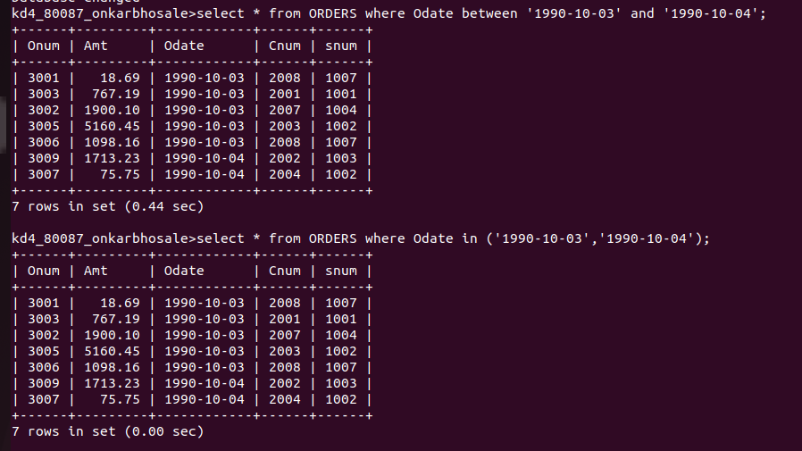

Q2) write a query that selects all of the customers serviced by peel
or motika (hint : the sum field relates the two row tables to one field relates the two tables to one another).
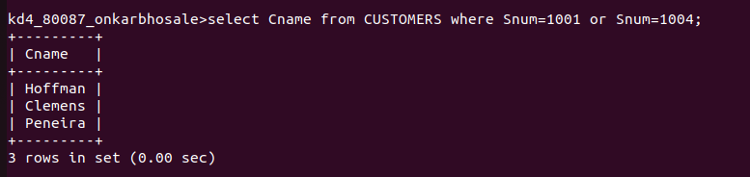

3) write a query that will produce all the customers whose names begin with a letter from ‘A’to ‘G’.
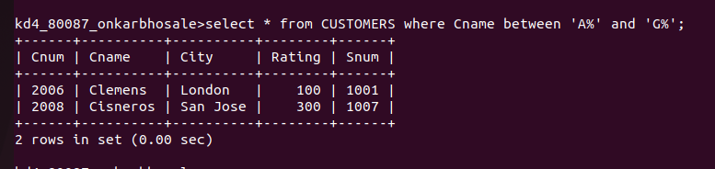

4)Write a query that selects all customers whose names begin with the letter ‘C’
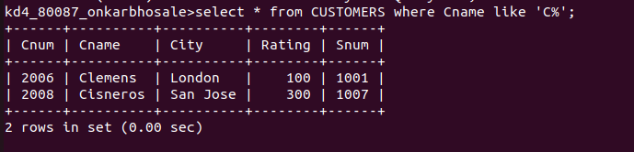
5)Write a query that selects all orders except those with Zeroes or Nulls in the amt field.

